Lab:
Automating a course search test with Selenium IDE

Objective:
Use Selenium IDE to record and execute a test case that verifies text appearing on the QA site.

Steps:
- Open Selenium IDE
  - If not installed, download and install the Selenium IDE browser extension for Chrome or Firefox.
  - Launch Selenium IDE and create a new project.
- Start Recording
  - Click the Record a new test in a new project option.
  - Enter the test URL: https://www.qa.com/
  - Click Start Recording (this opens the QA website in a new tab).
- Perform the Login Steps
  - Click open the search bar and type Java
  - Select the first link
  - Assert some text on the screen like:
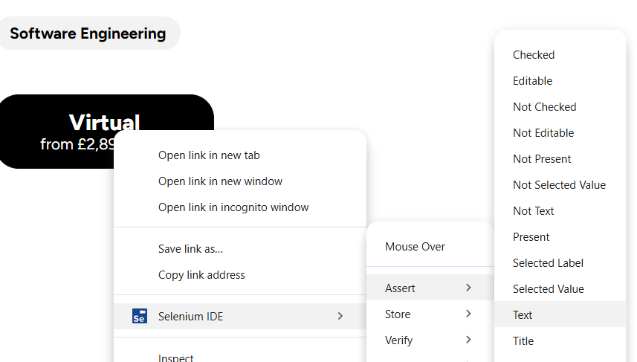

- Stop Recording & Save Test
  - Click the Stop Recording button in Selenium IDE.
  - Choose a suitable name for the test case.
- Run the Test
  - Click Run Current Test and observe the execution.
  - The test should pass if everything works correctly.

Go further:
- Modify the test to check what happens when the assert text is incorrect.

Export the test
- Export the test in C# or Java.
- Save the exported test. You will use the exported code in the next lab.

